Project Report Template

1. **Introduction:**
   1. **Overview:**

Job application tracking system is software for recruiters and employers to track candidates throughout the recruiting and hiring process.

* 1. **Purpose:**

It designed to help ease the time burden that hiring requires and many companies to find the analytics.

**2. Problem Definition & Design Thinking:**

**2.1 Empathy Map**

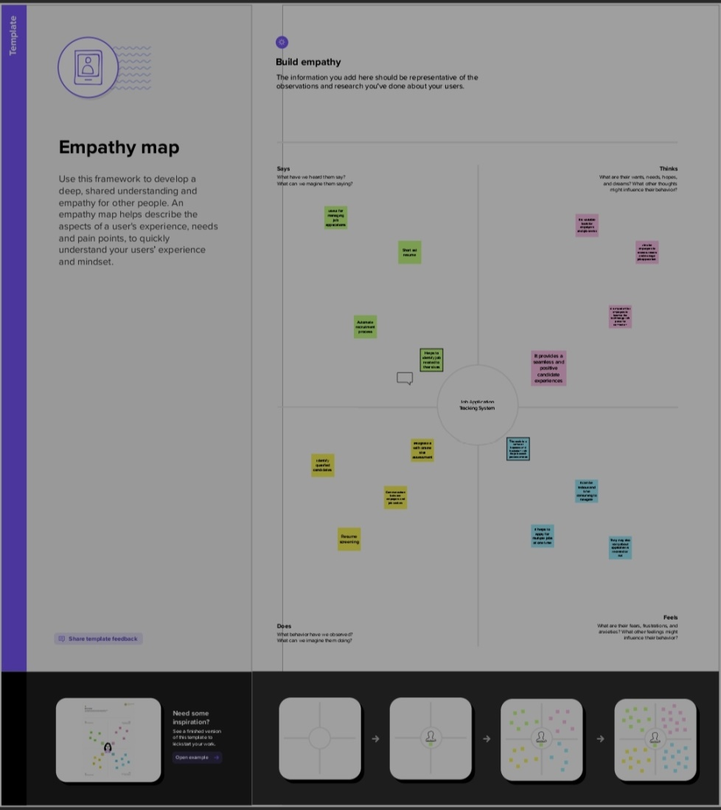

**2.2 Ideation & Brainstorming Map:**

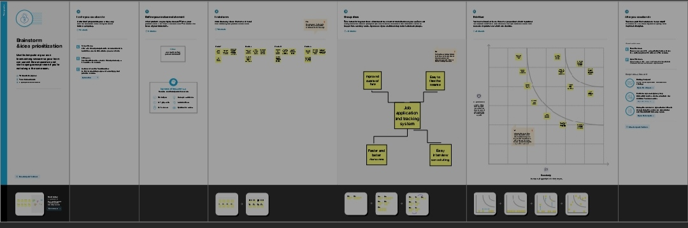

**3.Result:**

**3.1 Data Model:**

|  |  |
| --- | --- |
| **Object name** | **Fields in the object** |
| Recruiter | |  |  | | --- | --- | | Field Label | Data Type | | Description | Text Area | | Job Title | Text | | Location | Text | | Recruiter | Master-Detail | | Recruiter number | Auto Number | |
| Jobs | |  |  | | --- | --- | | Field label | Data Type | | Job Number | Auto Number | | Owner | Look up | |
| Candidate | |  |  | | --- | --- | | Field label | Data Type | | Candidate Number | Auto Number | | Owner | Look up | |
| Job Application | |  |  | | --- | --- | | Field Number | Data Type | | Job Application Object Name | Auto Number | | Owner | Look up | |
| Tab | |  |  | | --- | --- | | Field Number | Data Type | | Owner | Look up | | Tab Number | Auto Number | |

**3.2 Activity & Screensho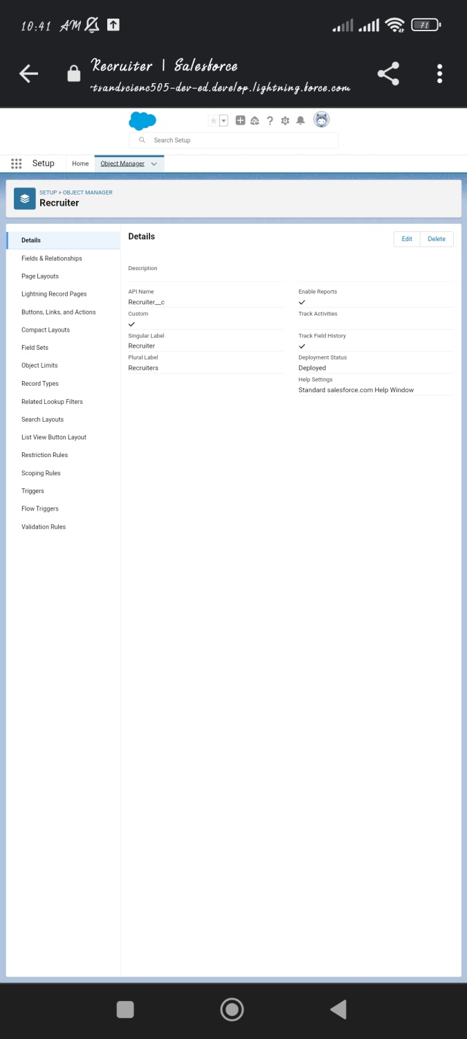t:**

To create an object first login to salesforce and click on gear icon and then setup ,then click object manager tab beside home tab then select custom objects.

For eg for recruiter we should create the object as shown below

Label: Recruiter

Plural Label: Recruiters

Record Name: Recruiter Name

Check allow report and allow search checkbox. Now save. Similarly create the custom objects Candidate, Job application, Job and Tab as follows

Next we have create custom tab for custom object. First click on tab click new for object click recruiter and choose any icon on your wish and save. Similarly create all custom tab for all object.

Field and relationship:

To create field and relationship go to setup and click object manager beside home tab and click on recruiter. Then select field and relationship just on the left side and click on new and create then select the data type as suitable for the object and after fill field label given board. Click + component and for report select the reports which have created already in the above process. Click them one by one. Then we should some data then only we can select vertical bar chart. For that go to app launcher go to Candidate with result card app which we have created. Then custom object will visible above click one by one and give detail on your wish and finally you get a page as shown below.

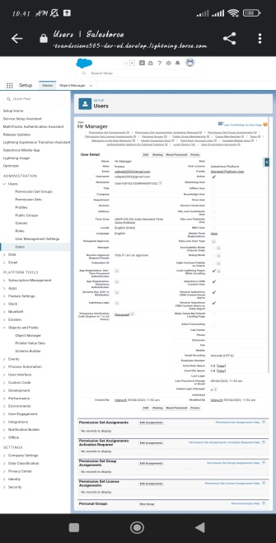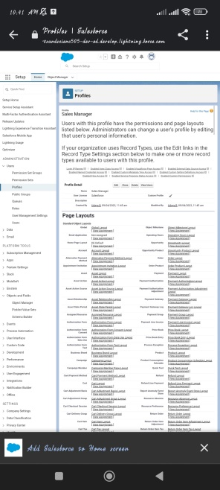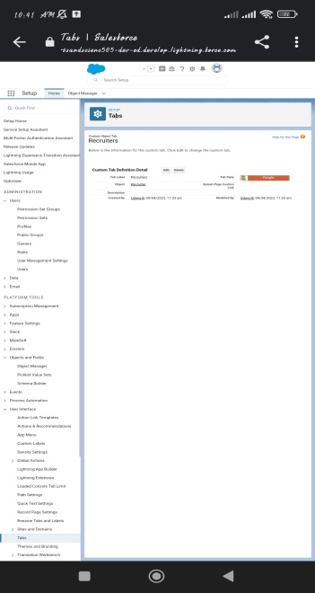

**4.Trailhead profile Public URL:**

Team Lead-<https://trailblazer.me/id/udayb28>

Team Member 1-<https://trialblazer.me/id/jerishaj7>

Team Member 2-<https://trailblazer.me/id/rashs12>

Team Member 3-<https://trailblazer.me/id/mshabana2>

**5. Advantages & Disadvantages:**

**5.1 Advantages:**

* Job application tracking system software allows you to automate various task of the hiring process that can save you a lot of time and free up your recruiting personnel for other high value task.
* It can be utilized to review application and filter out candidates that don’t meet the minimum requirements of the role.
* As an extension of the recruiting process, on boarding can be streamlined as well.

**5.2 Disadvantages:**

* When programming your recruiting software to recognize common key words arroun rules and responsibilities.
* You could end up filtering out good candidates that have atypical experience.
* This can happen with manual reviews as well,so automation, in most situation, has a net benefit.

**6.Applications:**

The areas where this Job application tracking system can be applied

**7.Conclusion:**

Job Application Tracking system for recruiters is a very effective hiring solution that most of the successful recruiters utilize.

**8.Future Scope:**

* Job application tracking system creates opportunities to automate manual process,increase visibility into the hiring cycle for the entire recruiting team, and increase opportunities for communication throughout the candidate journey.
* It report that it has improved the quality of the candidates they hire**.**